# CS 340 README Template

*Use this template to complete your README file. When completing the template, keep the headings as they are so that your document has a clear organization. Remove the italicized prompt text after you have completed each section for a polished final document.*

## About the Project/Project Title

*This project provides a visual interface for the AAC database. Additionally, this project could be adapted to function in a similar manner with other databases.*

## Motivation

*This project exists to allow people to more easily access the AAC database and to present the information in that database in a more intuitive manner, and provide some statistical analysis based on the data in the database.*

## Getting Started

*The first thing you should do is to follow this* [*ReadMe*](CS%20340%20project%201%20README.docx) *document which details the set-up process for the database, as well as establishing a user for the database, and explaining the functionality of the CRUD module which is the foundation for this project. Once you have finished the steps outlined in that document you can proceed. Once you have completed the necessary steps you can open the Project2.pynb file in jupyternotebook. Once the file is opened you should be able to rune it. Once the file has been run, it will provide you with a link to the database interface. Once the file has been run this link should be good indefinitely, unless you shut down the device you are using. If this does happen simply run the file again and the link will work as it did before.*

## Installation

*You will need Mongo, Jupyter notebook, as well as the pymongo, dash libraries and bson.objectid libraries. To install mongo, you should follow this* [*guide*](https://www.mongodb.com/docs/manual/tutorial/install-mongodb-on-windows/)*. You can install Jupyter notebook with this* [*guide*](https://jupyter.org/install)*, you can install pymongo with this* [*guide*](https://medium.com/@pragya_paudyal/connecting-mongodb-to-jupyter-notebook-e3f636a85830#:~:text=Open%20a%20jupyter%20notebook%20and,we%20need%20to%20create%20MongoClient.)*, and finally, you should be able to install dash, and bson with a similar command to the one listed in the pymongo guide. Once the software is set up you can establish your database, and from there you should adjust the variables mentioned above so you can access your new database.*

## Usage

*This project allows the user to view data contained in the AAC database [1]. The interface also has functions to sort data [2], as well as search for data entries in a given column [3]. Additionally, the user can switch between viewing the entire database, viewing entries related to water rescue animals, mountain rescue animals [4], and disaster rescue animals [5]. Additionally, the interface displays a geolocation map showing the location of a selected entry [6], as well as a pie chart that breaks down the ratio of the various breeds represented in the AAC database [7].*

*1:*

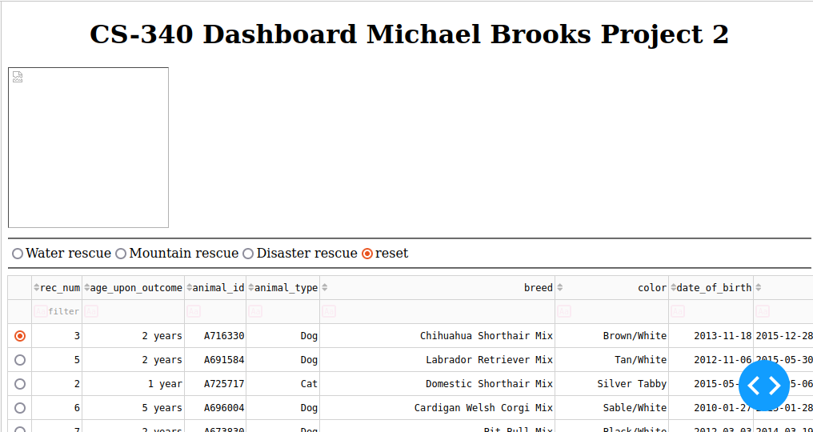

*2:*

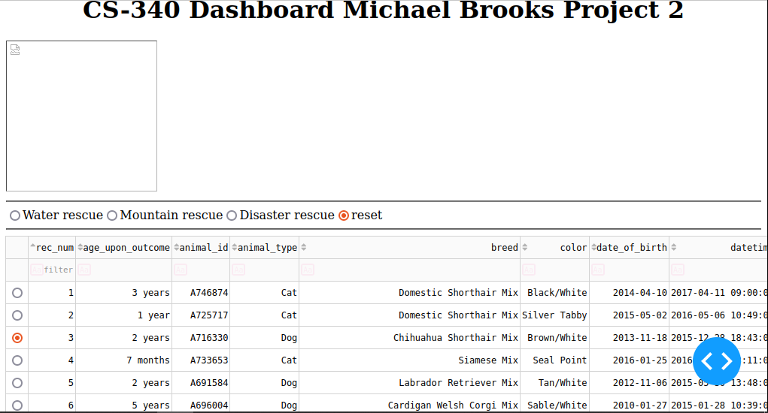

*3:*

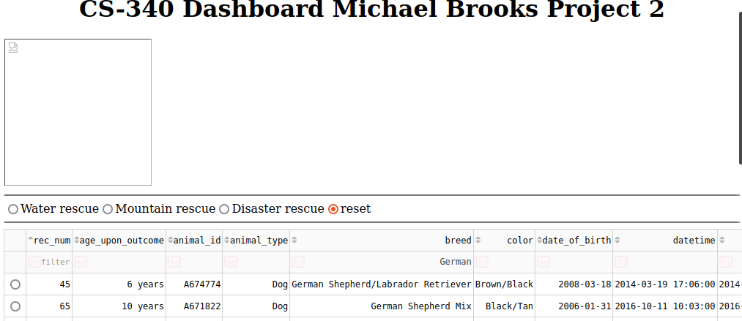

*4:*

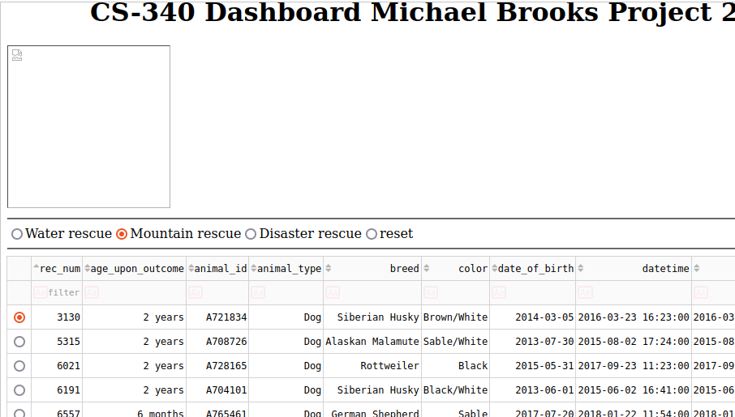

*5:*

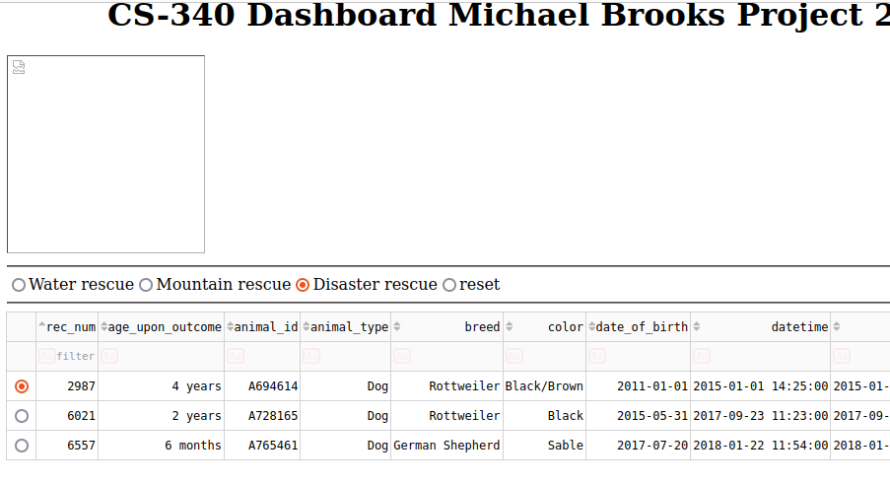

*6:*

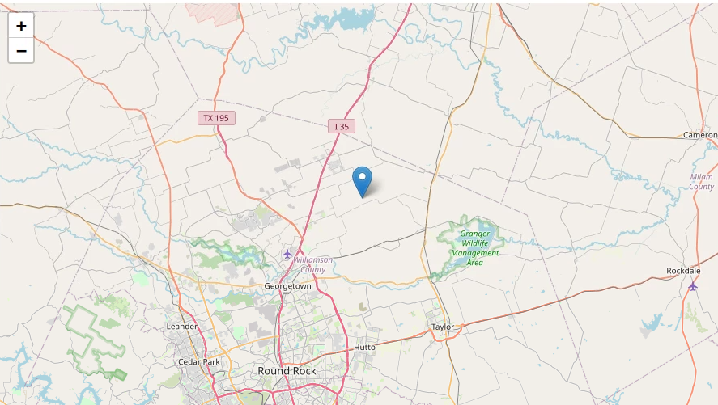

*7:*

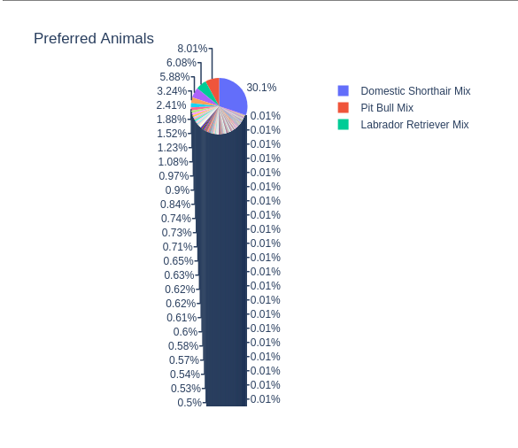

### Code Example

*Show what the library does as concisely as possible. Developers should be able to figure out how your project solves their problem by looking at the code example. Make sure that your code is short and concise.*

### Tests

*The tests are quite simple, simply click the radio buttons and view the table’s changes. Try sorting the column of the table, then try searching in the a given column. Watch the table change as you perform these actions. Additionally, you can select different rows and see the geolocation map change where its’ marker is placed. You can look over the data presented and see if it meets the expected outcome.*

### Screenshots

*Provide screenshots that demonstrate your work.*

*Base table:*

**

*Column sort:*

**

*Column search:*

**

*Radio button test:*

**

**

*Geolocation map test:*

**

## 

## Design Process:

The first step in constructing this project was to incorporate the CRUD module, as well as the AAC database into a browser window. This would develop into what you might call the front end of the database. The first thing I worked on was making the table, and adding the functionality you see above. Once the table was settled. I moved on to the geolocation map. This was certainly an interesting function and I believe it is one our users will enjoy. After the geolocation map was completed, I worked on adding the radio buttons that would alter the table created earlier on in the project. Once the radio buttons were in place, I worked on adding the pie chart that details different breeds of animals. Once the pie chart was done, I spent the rest of my available time debugging and testing the functionality of the project.

Development Road Blocks:

I encountered quite a few challenges developing this project, possibly my greatest challenge was sorting out the queries for the radio buttons. I knew what I wanted them to look for, and I more or less knew how it should be laid out, however I had quite a bit of trouble sorting out the syntax for this query, additionally, I encountered a reoccurring error that resulted in the query returning no values when certain conditions were posed to it. Specifically, when using the water rescue radio button. One of my other road blocks would be that the pie chart does not update like I wanted it too. I would have liked for it to be dynamic and interactive like the geolocation map, but my deadline was fast approaching and I key features that needed sorting out. Another road block that puzzled me was that I could never get my image to display on the webpage. This facet seemed the least integral to the function of the project, so it fell to the bottom of my priority list.

## Contact

Your name: Michael Brooks